Smyrna Police Department
Easter Egg Hunt
George Wright
Municipal Park
Saturday, March 24
1 p.m. – 2:30 p.m.

- Egg Hunt (Ages 1 - 8) (bring basket)
- Free Face Painting
- Food Trucks (cost)
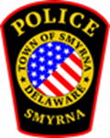
Easter Bunny Photos (bring your camera)
You must have a ticket to enter the event. Tickets are free and can be retrieved at: https://www.eventbrite.com/o/smyrna-police-department-13063191695

