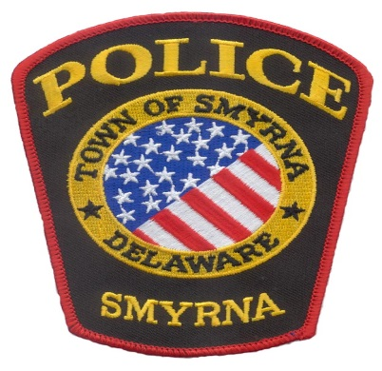
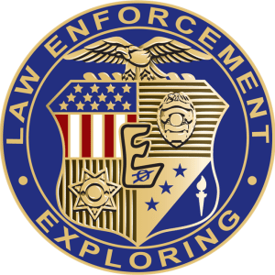
SMYRNA POLICE DEPARTMENT
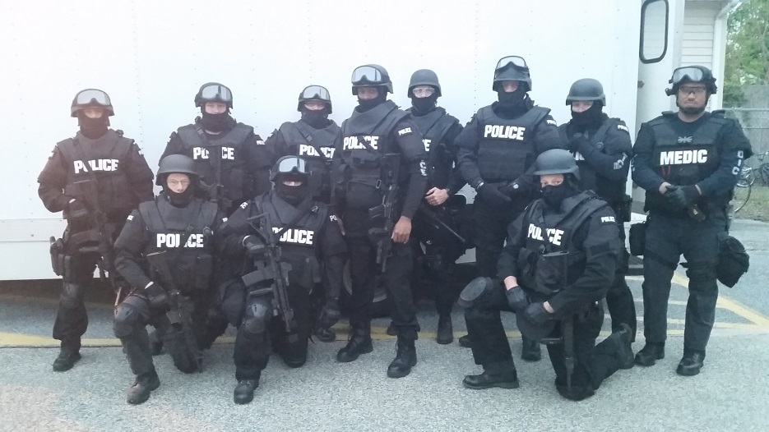
Explorer Post #58 Open House

Interested in a career in
Law Enforcement or Leadership Training?
Students ages 14 - 21 are invited
to attend the

Smyrna Police Department
Explorer Open House

September 19, 2017
7:00 pm - 8:00 pm
Questions? Contact Detective Michael Carrigan at
302-653-9217 or michael.carrigan@cj.state.de.us

Smyrna Police Department Explorers
ARE YOU READY TO ANSWER THE CALL?
If you have an interest in law enforcement, interested in leadership training, or just about a career in law enforcement, then you may want to be a Smyrna Police Department Explorer. There will be a $40 annual fee.

Qualifications
Citizenship: Must be a citizen of the United States.
Age: 14-21 years of age or completion of the 8th grade.
Academics: Must maintain a GPA of 2.0 or greater.
Criminal Record: No serious criminal history.
Drug Use: Use of illegal drugs and/or alcohol prior to or during appointment could be grounds for disqualification.
Driver Record: Applicants who have possessed or currently possess a driver’s license will have the records reviewed to determine history of driving behavior. Suspension(s), revocations, or excessive violations could result in disqualification.
Applications: A Learning for Life and Smyrna Police Explorer Application must be completed.

Benefits/Opportunities
Develop self-discipline/structure and leadership/serve the community/promotion and awards/ride alongs/scholarships and grants/department issued uniforms/work with active Patrol Officers and Detectives/Meet others with similar interests/police scenarios/shape the Explorer Program for future Explorers.

