Smyrna Police Department
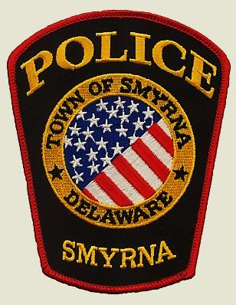 | CITIZENS POLICE ACADEMY
Are you interested in learning more about the Smyrna Police Department and your community? We are offering a free 10-week Citizen’s Police Academy starting this April!
Where: Smyrna Police Department
When: Wednesdays (April 26th - June 28th)
Time: 5:30 p.m. to 8:00 p.m.
Topics Covered Include:
• Community and Police Relationships
• Arrest-Search-Seizure
• Traffic and DUI Laws and Investigations
• Drug Laws and Investigations
• Shoot or Don’t Shoot Scenarios Defensive
• Tactics and Weapons Safety
If you are interested and wish to apply, please complete the academy application and return it to the Smyrna Police Department, attention: Detective Jessica Weller prior to April 14, 2017. All applicants are subject to a background check. Questions please contact Detective Weller at 302-653-9217 or Jessica.Weller@cj.state.de.us

